Multi-class Emotion AI by reconstructing linguistic context of words
A Project Report
Submitted in partial fulfilment of the requirements for the award of the degree of
Bachelor of Technology
In
Department of Computer Science and Engineering
by
Farhaan Ahmed Shaik | 14003352
M. Naga Teja | 14003348
K. Uday Kiran Reddy | 14003207
K. Subhani | 14003766

Under the supervision of
K. Sripath Roy
Asst. Professor

Department of Computer Science and Engineering
KONERU LAKSHMAIAH EDUCATION FOUNDATION
Green Fields, Vaddeswaram- 522502, Guntur (Dist), Andhra Pradesh, India.
2017- 2018

CERTIFICATE

This is to certify that the project report entitled “Multi-class Emotion AI by reconstructing linguistic context of words” is being submitted by Farhaan Ahmed Shaik (14003352), M.Naga Teja (14003348), K.Uday Kiran Reddy (14003207), K.Subhani (14003766), in partial fulfilment of the requirements for the award of the B.Tech in Computer Science and Engineering to K L University is a record of bonafide work carried out under our guidance and supervision.
The results embodied in this report have not been copied from any other department/ University/ Institute.

Signature of Project Guide | Signature of Head of the Department
K. Sripath Roy | V. Hari Kiran
Asst. Professor, ECE | HOD, CSE

EXTERNAL EVALUATOR

Koneru Lakshmaiah Education Foundation
Department of Computer Science and Engineering
Greenfields, Vaddeswaram

DECLARATION

This is to certify that the project report entitled “Multi-class Emotion AI by reconstructing linguistic context of words” is being submitted by Farhaan Ahmed Shaik (14003352), M.Naga Teja (14003348), K.Uday Kiran Reddy (14003207), K.Subhani (14003766), in partial fulfilment of the requirements for the award of the B.Tech in Computer Science and Engineering to K L University. The results embodied in this report have not been copied from any other department/ University/ Institute.

Farhaan Ahmed Shaik | 14003352
M. Naga Teja | 14003348
K. Uday Kiran Reddy | 14003207
K. Subhani | 14003766

Place:
Date:

ACKNOWLEDGEMENTS

We are very thankful to our project guide Mr. K. Sripath Roy, Asst . Professor for his continuous support and encouragement in the completion of Project work. His effort was enormous and his guidance showed us a path to find the solution.
We take immense pleasure in expressing our gratitude to our head of Department, CSE, Mr. V. Hari Kiran for his priceless words of encouragement towards achieving the success in the completion of project work.
We express our heart full gratitude to our President Dr. Koneru Satyanarayana, Chancellor Dr.M.Ramamoorty, Vice Chancellor Dr.L.S.S Reddy, Pro-Vice Chancellor Dr. A.V.S.Prasad and our beloved Principal Dr. Anand Kumar for providing infrastructure facilities in pursuing this project.
We thank all the Open Source Contributors who have provided us with the resources for the easy completion of the project mainly KLUG. Their effort in clarifying our doubts and giving proper guidance towards completion of the project is enormous.
We thank all Teaching and Non-Teaching Staff of our department and especially our classmates and our friends for their support in the completion of our project work.

Farhaan Ahmed Shaik | 14003352
M. Naga Teja | 14003348
K. Uday Kiran Reddy | 14003207
K. Subhani | 14003766

INDEX
Chapters | Page No
Abstract | 08
Chapter 1 : Introduction | 10-11
Chapter 2 : Proposed Techniques | 12-16
Chapter 3 : Flow of Process | 17-18
Chapter 4 : Implementation | 19-24
Chapter 5 : Source Code | 25-41
Chapter 6 : Output | 42-46
Chapter 7 : Conclusion and Future Scope | 47-48
Chapter 8 : References | 49-50
Chapter 9 : Published Paper | 51-57

LIST OF FIGURES
Fig no. | Description | Page. No.
1.1 | Sentiment analysis | 11
2.1 | Types of Sentiment analysis | 13
2.2 | Types of Machine learning | 14
3.1 | Flow chart | 18
4.1 | Twitter Login | 20
4.2 | Creating Application | 21
4.3 | Account | 21
7.1 | Output of 7000 tweets with TF-IDF Word2vec | 43
7.2 | Bar Chart -1 | 43
7.3 | Output of 7000 tweets with Word2vec | 44
7.4 | Bar Chart -2 | 44
7.5 | Output of 5000 tweets with TF-IDF Word2vec | 45
7.6 | Bar Chart -3 | 45
7.7 | Output of 5000 tweets with TF-IDF Word2vec | 46
7.8 | Bar Chart -4 | 46

ABSTRACT
In today’s technological world, Social networking websites like Twitter, Instagram, Facebook, Tumblr, etc. play a very significant role. Emotion AI is about dealing, recognizing and analyzing sentiments or opinions conveyed in a person’s text. In particular Emotion is most frequently called Sentiment analysis. It helps us to understand the people’s point of view. A vast amount of sentiment rich data is produced by Social networking websites in the form of posts, tweets, statuses, blogs etc. Some users post reviews of certain products in social media which influences customers to buy the product. Companies can use such review data analyze it and improve the product. Sentiment analysis of Twitter is troublesome correlated to other social networking websites because of the existence of a lot of short words, misspellings and slang words applying emotion analysis to such data is more challenging. We have classified the sentiment into 5 categories. Machine learning strategies are preferred mostly for analyzing emotion AI. We have used neural network model word2vec with TF-IDF approach to predict the sentiment of the tweet.

CHAPTER-1
INTRODUCTION

1. INTRODUCTION
Technology is developing day-by-day because of the Internet. The Internet is a worldwide communication network with this, usage of social websites like Twitter, Facebook, Instagram, Tumblr etc. have increased. In fact, social websites have become a famous place where everyone expresses their opinion about anything i.e. either it may be a product or article or society issues. Everyone has right to express their feeling and many of them think a social website is the best place to express their feelings in the form of the social networking blogs, Tweets, posts, statuses etc.
The Sentiment analysis focuses on the utilization of regular dialect handling, and furthermore message investigation of tremendous amounts of data. This sentimental analysis sometimes alluded as emotion Artificial Intelligence. It is the study of affective states and emotions present in the given information. The sentimental analysis is applied to various aspects of the web such as client audits and reviews.
Sentiment Analysis or Emotion AI is a mechanism for ‘computationally’ resolving or recognizing if certain text is neutral, negative or positive. In general terms, sentimental analysis aims to find the attitude of a customer expressed in a text. Sentiment analysis is again called as Opinion mining that is computing the sentiment or opinion of the person. Sentiment analysis is used to establish the person's opinion towards a product or problem with the help of variables such as emotion, tone and context, etc. Business corporations value this approach to compute and investigate the public opinion of their products and company to improve the customer satisfaction towards them. Business corporations further use this opinion mining approach to collect critical opinion about a new product and identifying the problems in it. Sentiment analysis is used by the major multinational companies to obtain the impression on their products and with the help of that, they can design their business strategies. Twitter is one of the platforms where people post the opinion on major real-world subjects, current affairs, etc. The social media websites like Facebook, Twitter and Instagram produce trillions of megabytes of data 24/7. This vast amount of data is interpreted to figure out the sentiment of people on various problems. Although a lot of research is done in sentiment analysis our developed model is one of its first kind as we have taken multi-classes in emotions of sentiment analysis and predicted the emotion with the help of Machine learning models. Machine learning is simply training the machine with previous set of data and predicting the future data. Machine learning is the most booming technology these days and is applied in various fields. There are various machine learning techniques that can be applied to Sentiment analysis. Through our study of multi-class sentiment analysis we found that distance calculation between words and by reconstructing linguistic context of words we can predict the emotion more effectively.
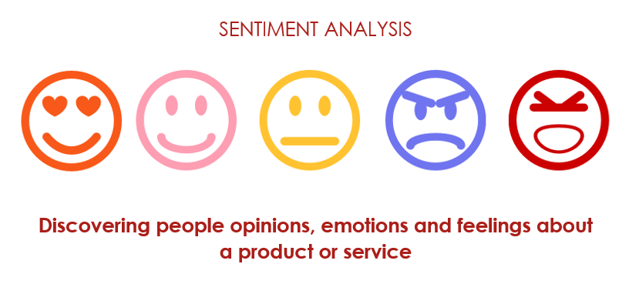
Fig.1.1 Sentiment analysis

CHAPTER-2
PROPOSED TECHNIQUES

2. Proposed techniques
Sentiment Analysis or emotion AI can be performed using two approaches that are lexicon based approach and machine learning approach.
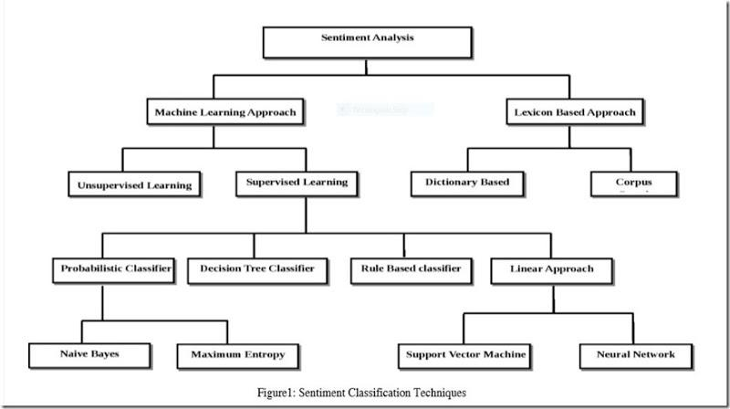
Fig.2.1 Types of Sentiment analysis
2.1 Lexicon Based Approach
In lexicon based approach a set of words are collected to form a dictionary or a word corpus. These words are separated according to the base word sentiment manually and are placed into multi-array. The tweet to predict the sentiment is taken and each word in the tweet is compared with the multi-sentiment arrays. A count of each sentiment is maintained and as a match of word occurs with a word in sentiment array the count of that sentiment is increased. Further if a tweet contains more number of positive words the tweet is predicted to be positive with the help of the sentiment count.
2.2 Machine Learning based Approach
In Machine learning based approach a data set of previous tweets is obtained and is manually annotated with the sentiments. An appropriate Machine learning algorithm is chosen and applied to the trained data set i.e. Manually annotated tweets and a set of user chosen tweets are predicted for sentiment with the help of the machine learning algorithm used. The machine learning approach we have adopted is word2vec which reconstructs the linguistic context of words by calculating the distance between words with the help of Euclidean distance and predicts the sentiment by finding the nearest tweet of the data corpus. Machine learning can be of different types based on the approach.
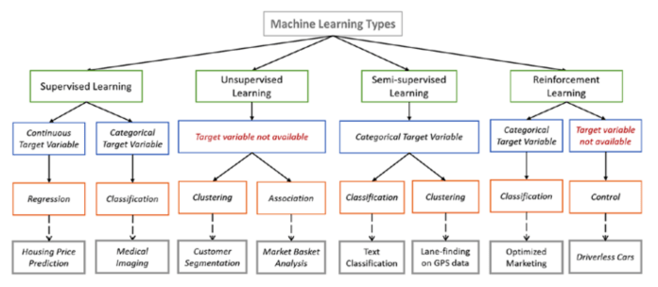
Fig.2.2 Types of Machine learning
2.3 Euclidean Distance
In order to calculate the distance between two points, Euclidean is used. Euclidean distance will play a significant role to calculate the distance between words. Euclidean distance is used in many of classification algorithm such as K-Nearest Neighbour, Minimum Distance Classifier, TF-IDF etc. let p1 at (x1, y1) and p2 at (x2, y2), in a plane then the Euclidean can be calculated with the help of Pythagoras theorem by:
Distance =
2.4 TF-IDF
Tf-idf is an acronym for term frequency-inverse document frequency, it’s a way to grade the significant terms (or "words") in a document based on how often these terms appear across the whole document and across multiple documents and the tf-idf weight usually used in data retrieval and text data mining. Computing sum of tf-idf for each term is one of the simplest approaches.

2.4.1 Term Frequency (TF)
It computes how often a word or term appears in a record. Since every record is divergent in length, it is possible that the term appears more times in some documents than others. Term frequency can be calculated by how frequent a term t occurs in a record, normalized by dividing by the total number of terms in that record.

2.4.2 Inverse Document Frequency (IDF)
It computes how common a word is among all records, at the same time measuring Term frequency, every word is scrutinized as equally essential. Despite, there are certain common words like "the", "for", "is", "of" and "that" which appear in many documents very frequently but have little significant. Therefore we compute IDF by:

2.5 WORD2VEC model
Word2Vec is a cluster of models which helps derive associations between a term and its contextual terms or words. The cluster models are hollow, two-layer neural networks that are schooled to reestablish linguistic contexts of words. The two important model architectures inside are Skip-grams and CBOW. Word2vec model can be built with the help of Tensor flow, it is an open source machine learning framework developed by Google for research purpose.
2.5.1 Skip-gram
In Skip-gram model, a center word and a window of context (neighbor) words are chosen and context words are predicted out to some window size for each center word. So, the model goes to outline a probability distribution i.e. probability of a word occurring in the context given a center word and vector representations is chosen to maximize the probability.
2.5.2 Continuous Bag of Words (CBOW)
In Actual terms, this is a mirror of skip-gram. In CBOW, we predict center word by summing vectors of surrounding (Neighbour) words. Essentially, we begin with small random initialization of word vectors. In Word2vec, we have a large matrix with each row for the “words” and columns for the “context”. CBOW is not sequential and does not have to be probabilistic.

CHAPTER-3
FLOW OF PROCESS

3. Flow of process
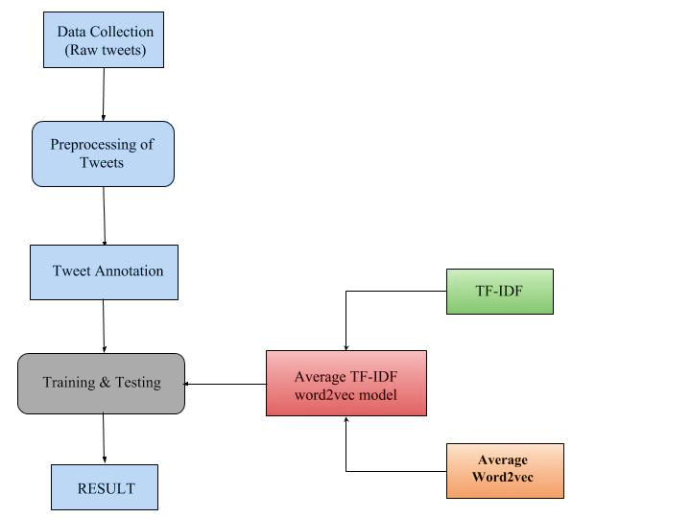
Fig.3.1 Flow chart
This process flow is further explained in the chapter of implementation each block step by step till the final result is obtained.

CHAPTER-4
IMPLEMENTATION

4. IMPLEMENTATION
4.1 Data collection
Collection of data is one of the biggest tasks in sentiment analysis. Twitter data is abundantly available on twitter official website. Twitter provides a standard search API for research purpose. Access_token_ secret, Access_token, Consumer_secret and Consumer_key are required to access the Twitter API, We have developed a simple python script called Tweet crawler with the Twitter API access keys and used it to download the specific tweets of a topic from the Twitter API to form the dataset. This raw dataset obtained through python script is cleaned and processed for prediction.
The process to obtain these keys is.
- Log in to your twitter account using the following link https://apps.twitter.com/. The interface looks like this
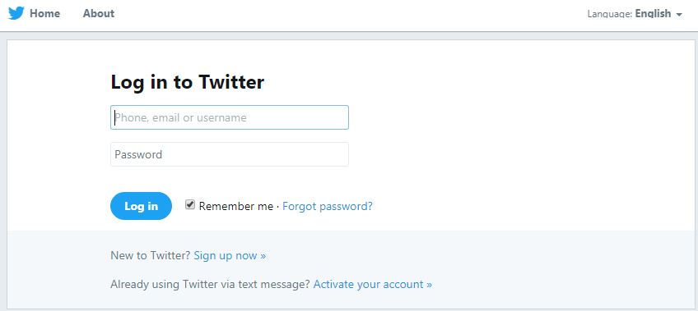
Fig 4.1 Twitter Login
- In the above shown interface you should click the option button named “Create New app”, then the interface changes and displays a form which you should fill in order to continue creating your application in twitter.
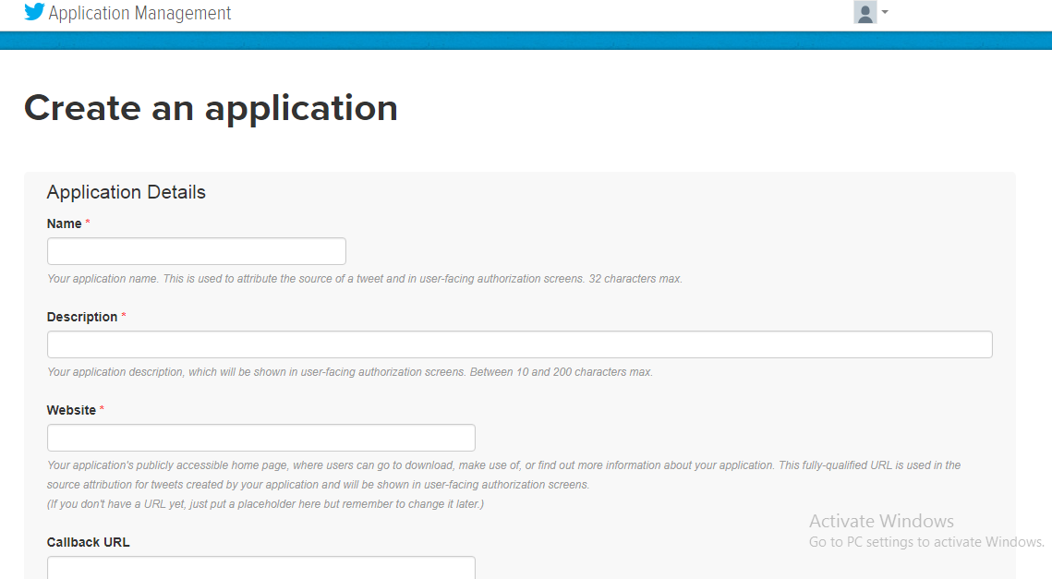
Fig 4.2 Creating Application
- After filling the above displayed form next step is to choose your app name and a textbox is given to fill in your app description.This website requires you to enter a valid URL . A default URL http://test.de/ in case if we do not have our own created URL.Then it shows a Developer Agreement, read all the information presented in the agreement and then if you want to proceed then click on “Yes, I accept” button. Then the screen appears like this one shown below.
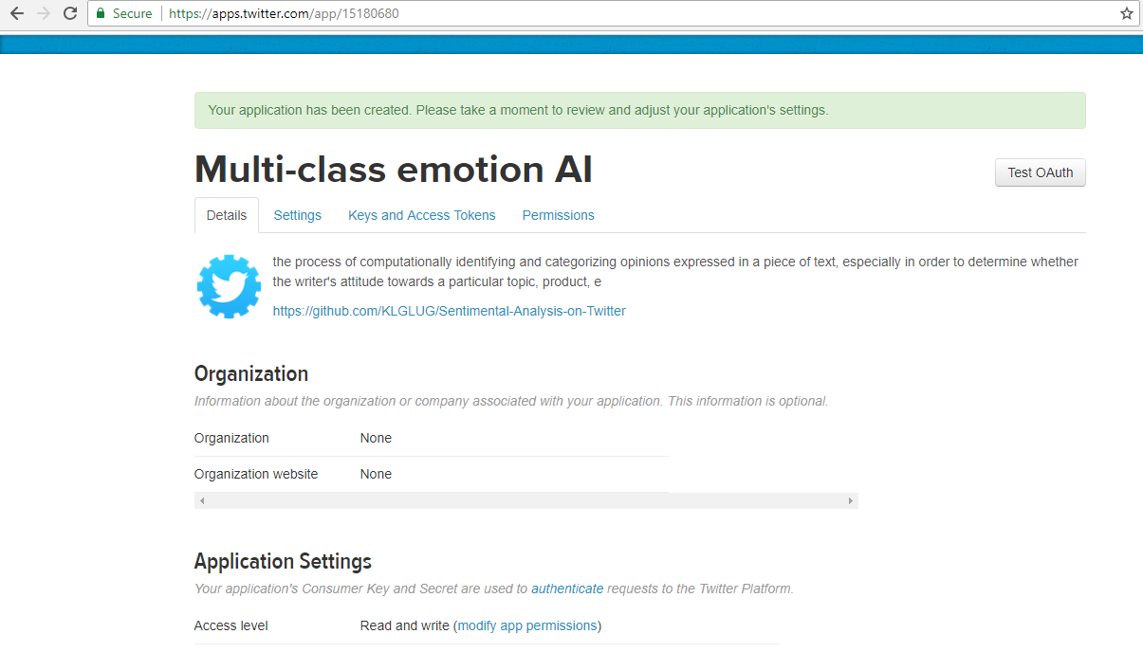
Fig 4.3 Account
- In this interface it shows multiple options like Details, Settings, Keys and Access Tokens and Permissions. Next step is to click on Keys and Access tokens, then consumer key, consumer secret key, access level, owner, and owner ID can be seen on your application API screen. After scrolling down further there appears a section named Your Access Token, then in that section click “create my access token”.
- In such a way Twitter API access keys are obtained.
4.2 Data pre-processing
In Sentiment analysis, preprocessing of data plays a vital role as data always may not be in the exact (meaningful) form for analysis. Twitter data preprocessing is more significant as it consists of slang words, misspellings, #tags, @tags, hyperlinks and shortcut words. So we use various processing techniques like:
- Removing duplicates i.e. retweets and repeated tweets that are downloaded.
- Replacing the Null values with Zeros.
- Tweet of length less than 3 are deleted.
- Tags and hyperlinks have been eliminated.
- Stemming or lemmatization to obtain the base word.
- Removing stop words from each tweet.
Caution is required when removing stop words and lemmatization because some words like Not, Very, Limit etc. make sense in many statements. For overcoming this problem we use bigrams or trigrams instead of unigrams. Sometimes with Stemming or lemmatization, the base word obtained is not relevant to the tweet, such problems should be specifically checked.
4.3 Tweet Annotation
Generally, the output of sentiment analysis of any statement falls into three categories, they are positive, negative and neutral. Since the chosen dataset is on Airlines review tweets, we add two more essential categories question and suggestion. Since new categories added auto-annotation of emotion is not possible. So, each tweet is manually annotated. Tweets sometimes consist of both positive and negative or a negative and question but general sentiment analysis only assigns a single outcome to the tweet. As an improvement to this, multiple assignments to each tweet is done, For example:

- “@united I have such a love-hate relationship with you. Some days you're good, the others you are so terribly awful it's saddening”. We annotate such tweet as both Positive and Negative.

- “@VirginAmerica, you're doing a great job adding little luxuries/aesthetics that improve the air travel experience. Thank you. Keep it up!”. We annotate such tweet as both Positive and Suggestion.

- “@SouthwestAir, been on hold for an over an hour now - when can we expect some customer service? #disappointed”. We annotate such tweet as both Negative and Question.

4.4 TF-IDF word2vec model
Word2vector is a super-powerful representation of words and it somehow catches the semantic relationship in d-dimension vector. Word2vector gives Dense network i.e. most of the cells are non-zero.Word2vector learns the Data corpus through Word-Content or context. Suppose , , , , are the words in a corpus then in order to compute i.e. occurs in the context of the set of 5 words chosen. Let , , , , are the words in a tweet. So, We form 300 dimension vector for every word from Google's model and we add all these vectors (++++) and divide that with total no of words let it be K ((++++)/K). With this, we get a single vector of size 1*300 dimension for every tweet. For this algorithm, we need a large data corpus i.e. in billions or millions.
Since only limited data is available it is not feasible to build a word2vec model of our own. Instead, it is preferred to use Google's word2vector model. It consists of 3 billion words and each word is associated with 1X300 size vector. By using this model we create a combined model of “word2vec" and "TF-IDF" to form TF-IDF word2vec model.
4.5 Training & Testing dataset
After annotation of the dataset, we break the dataset into a couple of parts, Training data and Testing data. The number of tweets in the training data should be always greater than the testing data for the better result. Each tweet from test dataset is matched with a similar tweet from train dataset with the help of the constructed model “TF-IDF Word2vec” and various distance calculation algorithms like Euclidean distance, Manhattan, Minkowski, Hamming, cosine similarity and cosine distance. It is found that Euclidean distance is far better than others after multiple trails on the airline's dataset. We predict the class variables by using the above technique i.e. Euclidean distance and assign the same values as the near tweet consists of the test tweet. By using these similarity-based techniques we predict the sentiment of each user data or tweet.

CHAPTER-5
SOURCE CODE

5. SOURCE CODE
5.1 Tweet Crawler:

#importing required libraries
import twitter
import json
import csv
import re
import time
from urllib.parse import unquote

#Twitter API credentials
consumer_key = 'XXXXXXXXXXXXXXX'
consumer_secret = 'XXXXXXXXXXXXXXXX'
access_token = 'XXXXXXXXXXXXXXXXXXXXXXX'
access_token_secret = 'XXXXXXXXXXXXXXXXXXXXXXXXXXXx'

auth = twitter.oauth.OAuth(access_token, access_token_secret,consumer_key,consumer_secret)
twitter_api = twitter.Twitter(auth=auth)
#input Hashtag
query = input("Hashtag:")
#number of tweets required as count
max_count = int(input("Count:"))

search_results = {}
search_results["statuses"] = []
search_results["search_metadata"] = {}
#searching twitter API
search_results = twitter_api.search.tweets(q=query,count=max_count,lang = 'en')
statuses = search_results['statuses']
while(1):
if len(statuses)>=max_count:
break
if 'next_results' in search_results['search_metadata'].keys() and 'search_metadata' in search_results.keys():
next_results = search_results['search_metadata']['next_results']
else:
break
kwargs = dict([ kv.split('=') for kv in unquote(next_results[1:]).split("&") ])
try:
search_results = twitter_api.search.tweets(**kwargs)
except Exception as e:
time.sleep(910)
print('Slept, Continuing after exception:')
search_results = twitter_api.search.tweets(**kwargs)
statuses += search_results['statuses']
with open(query+str(int(time.time()))+'.csv', 'w') as csv_file:
writer = csv.writer(csv_file)
writer.writerow(["Tweet"])
for status in statuses:
#omiting the retweets
if 'RT' not in status["text"]:
#removing hyperlinks and @tags
status["text"] = re.sub(r"(?:\@|https?\://)\S+", "", status["text"])
#writing into csv file
writer.writerow([status["text"],""])

5.2 Sentiment analysis with average Word2vec model

# Importing the libraries
import numpy as np
import matplotlib.pyplot as plt
import pandas as pd
from nltk.stem import WordNetLemmatizer

# Importing the dataset
dataset = pd.read_csv('newtweet1.csv')
#dataset.fillna(0,inplace=True)
# Cleaning the texts
import re
import nltk
#nltk.download('stopwords')
from nltk.corpus import stopwords
from nltk.stem.porter import PorterStemmer
import pickle
from sklearn.metrics import pairwise_distances
from sklearn.metrics.pairwise import cosine_similarity
corpus = []
d1,d2,d3,d4,d5={},{},{},{},{}
for i in range(0, 5000):
review= dataset['Tweet'][i]
#review = re.sub('@[\w\d]*','',dataset['Tweet'][i])
if "#" in review:
review = list(review)
review.remove("#")
review.remove("@")
review = "".join(review)
review = re.sub('(?:https://|http://)[\w\d\.\/]*','',review).strip()
review = re.sub('[^a-zA-Z]', ' ', review)
review = review.lower()
review = review.split()
ps = PorterStemmer()
lemma = WordNetLemmatizer()
review = lemma.lemmatize(review)
review = [word for word in review if not word in set(stopwords.words('english'))]
for each_word in review:
if dataset['positive'][i]==1:
d1.setdefault(each_word,0)
d1[each_word]+=1
elif dataset['negative'][i]==1:
d2.setdefault(each_word,0)
d2[each_word]+=1
elif dataset['neutral'][i]==1:
d3.setdefault(each_word,0)
d3[each_word]+=1
elif dataset['question'][i]==1:
d4.setdefault(each_word,0)
d4[each_word]+=1
elif dataset['suggestion'][i]==1:
d5.setdefault(each_word,0)
d5[each_word]+=1
review = ' '.join(review)
corpus.append(review)

with open('word2vec_model', 'rb') as handle:
model = pickle.load(handle)

word2ven_matrix_of_titles=[]
for i in corpus:
j=i.split()
idf_avg = 0
l=np.zeros(300,dtype="int64")
for j1 in j:
if j1 in model:
j1_vec = model[j1]
l=np.add(l,j1_vec)
word2ven_matrix_of_titles.append(l/len(j))

X = np.array(word2ven_matrix_of_titles)
y = (dataset.iloc[:, 1].values).astype(int)
y1 = (dataset.iloc[:,2].values).astype(int)
y2 = (dataset.iloc[:,3].values).astype(int)
y3 = (dataset.iloc[:,4].values).astype(int)
y4 = (dataset.iloc[:,5].values).astype(int)

from sklearn.cross_validation import train_test_split
X_train, X_test, y_train, y_test = train_test_split(X, y, test_size = 0.1, random_state = 0)
X_train, X_test, y1_train, y1_test = train_test_split(X, y1, test_size = 0.1, random_state = 0)
X_train, X_test, y2_train, y2_test = train_test_split(X, y2, test_size = 0.1, random_state = 0)
X_train, X_test, y3_train, y3_test = train_test_split(X, y3, test_size = 0.1, random_state = 0)
X_train, X_test, y4_train, y4_test = train_test_split(X, y4, test_size = 0.1, random_state = 0)

predicted_values,y_pred,y1_pred,y2_pred,y3_pred,y4_pred = [],[],[],[],[],[]

for i in range(len(X_test)):
idf_w2v_dist = pairwise_distances(X_train, X_test[i].reshape(1, -1))
indices = np.argsort(idf_w2v_dist.flatten())[0:1][0]
y_pred.append(y_train[indices])
y1_pred.append(y1_train[indices])
y2_pred.append(y2_train[indices])
y3_pred.append(y3_train[indices])
y4_pred.append(y4_train[indices])
predicted_values.append([y_train[indices],y1_train[indices],y2_train[indices],y3_train[indices],y4_train[indices]])

k=list(dataset["Tweet"][len(X_train):5003])
l5=[]
for i in range(len(predicted_values)):
l5.append((k[i],predicted_values[i]))
dataFrame = pd.DataFrame(data=l5,columns=["tweet","centi"])

from sklearn.metrics import confusion_matrix
cm = confusion_matrix(y_test, y_pred)
cm1 = confusion_matrix(y1_test, y1_pred)
cm2 = confusion_matrix(y2_test, y2_pred)
cm3 = confusion_matrix(y3_test, y3_pred)
cm4 = confusion_matrix(y4_test, y4_pred)

p=(cm[0][0]+cm[1][1])/500
p1=(cm1[0][0]+cm1[1][1])/500
p2=(cm2[0][0]+cm2[1][1])/500
p3=(cm3[0][0]+cm3[1][1])/500
p4=(cm4[0][0]+cm4[1][1])/500

print((cm[0][0]+cm[1][1])/500)
print((cm1[0][0]+cm1[1][1])/500)
print((cm2[0][0]+cm2[1][1])/500)
print((cm3[0][0]+cm3[1][1])/500)
print((cm4[0][0]+cm4[1][1])/500)
print((p+p1+p2+p3+p4)/5)

5.3 Sentiment analysis with TF-IDF Word2vec model

# Importing the libraries
import numpy as np
import matplotlib.pyplot as plt
import pandas as pd

# Importing the dataset
dataset = pd.read_csv('tweets@5k2.csv')
dataset.fillna(0, inplace=True)
# Cleaning the texts
import re
import nltk
#nltk.download('all')
#nltk.download('stopwords')
from nltk.corpus import stopwords
import pickle
from sklearn.metrics import pairwise_distances
from sklearn.metrics.pairwise import cosine_similarity
corpus = []
for i in range(0, 7002):
review = re.sub('@[\w\d]*','',dataset['Tweet'][i])
if "#" in review:
review = list(review)
review.remove("#")
review = "".join(review)
review = re.sub('(?:https://|http://)[\w\d\.\/]*','',review).strip()
review = re.sub('[^a-zA-Z]', ' ', review)
review = review.lower()
review = review.split()
review = [word for word in review if not word in set(stopwords.words('english'))]
review = ' '.join(review)
corpus.append(review)

for i in range(len(corpus)):
if len(corpus[i])==0:
print("hello")
print(i)

with open('word2vec_model', 'rb') as handle:
model = pickle.load(handle)
word2ven_matrix_of_titles=[]
for i in corpus:
j=i.split()
idf_avg = 0
l=np.zeros(300,dtype="int64")
for j1 in j:
if j1 in model:
j1_vec = model[j1]
l=np.add(l,j1_vec)
word2ven_matrix_of_titles.append(l/len(j))
import math
def find_tfidf_value(full,key):
count=0
for i in full:
if key in i:
count+=1
return math.log(len(corpus)/count)

word2ven_matrix_of_titles1=[]
for i in corpus:
j=i.split()
idf_avg = 0
l=np.zeros(300,dtype="int64")
for j1 in j:
if j1 in model:
idf=find_tfidf_value(corpus,j1)
tf=j.count(j1)/len(j)
j1_vec = model[j1]*(idf*tf)
l=np.add(l,j1_vec)
idf_avg +=idf*tf
else:
idf=find_tfidf_value(corpus,j1)
tf=j.count(j1)/len(j)
idf_avg +=idf*tf
if idf_avg==0:
idf_avg=1
word2ven_matrix_of_titles1.append(l/idf_avg)
word2ven_matrix_of_titles2= []
for i in range(len(word2ven_matrix_of_titles)):
word2ven_matrix_of_titles2.append(word2ven_matrix_of_titles[i]*word2ven_matrix_of_titles1[i])

X = np.array(word2ven_matrix_of_titles)
y = (dataset.iloc[:, 1].values).astype(int)
y1 = (dataset.iloc[:,2].values).astype(int)
y2 = (dataset.iloc[:,3].values).astype(int)
y3 = (dataset.iloc[:,4].values).astype(int)
y4 = (dataset.iloc[:,5].values).astype(int)

from sklearn.cross_validation import train_test_split
X_train, X_test, y_train, y_test = train_test_split(X, y, test_size = 0.2, random_state = 0)
X_train, X_test, y1_train, y1_test = train_test_split(X, y1, test_size = 0.2, random_state = 0)
X_train, X_test, y2_train, y2_test = train_test_split(X, y2, test_size = 0.2, random_state = 0)
X_train, X_test, y3_train, y3_test = train_test_split(X, y3, test_size = 0.2, random_state = 0)
X_train, X_test, y4_train, y4_test = train_test_split(X, y4, test_size = 0.2, random_state = 0)

predicted_values,y_pred,y1_pred,y2_pred,y3_pred,y4_pred = [],[],[],[],[],[]

for i in range(len(X_test)):
idf_w2v_dist = pairwise_distances(X_train, X_test[i].reshape(1, -1))
indices = np.argsort(idf_w2v_dist.flatten())[0:1][0]
y_pred.append(y_train[indices])
y1_pred.append(y1_train[indices])
y2_pred.append(y2_train[indices])
y3_pred.append(y3_train[indices])
y4_pred.append(y4_train[indices])
predicted_values.append([y_train[indices],y1_train[indices],y2_train[indices],y3_train[indices],y4_train[indices]])

k=list(dataset["Tweet"][len(X_train):7002])
l5=[]
for i in range(len(predicted_values)):
l5.append((k[i],predicted_values[i]))
dataFrame = pd.DataFrame(data=l5,columns=["tweet","centi"])

from sklearn.metrics import confusion_matrix
cm = confusion_matrix(y_test, y_pred)
cm1 = confusion_matrix(y1_test, y1_pred)
cm2 = confusion_matrix(y2_test, y2_pred)
cm3 = confusion_matrix(y3_test, y3_pred)
cm4 = confusion_matrix(y4_test, y4_pred)

print("\nRESULT:\n")
print("confusion matrix are:")
print(cm)
print(cm1)
print(cm2)
print(cm3)
print(cm4)
p=((cm[0][0]+cm[1][1])/1400)
p1=((cm1[0][0]+cm1[1][1])/1400)
p2=((cm2[0][0]+cm2[1][1])/1400)
p3=((cm3[0][0]+cm3[1][1])/1400)
p4=((cm4[0][0]+cm4[1][1])/1400)
print("\n")
print("Positive = {:.2f} %".format(p*100))
print("Negative = {:.2f} %".format(p1*100))
print("Neutral = {:.2f} %".format(p2*100))
print("Question = {:.2f} %".format(p3*100))
print("Suggestion = {:.2f} %".format(p4*100))
total= (p1+p+p2+p3+p4)/5
print("Total = {:.2f} %".format(total*100))

CHAPTER-6
OUTPUT

6. OUTPUT
In the dataset of 7000 Airline review tweets, 80% of the tweets are trained and 20% are tested or predicted. Below is the bar-chart (fig.7.2) which shows the overall number of tweets that are predicted correctly and the number of tweets that are predicted wrong. The combination of tf-idf and word2vec resulted in an 86.14% classification model accuracy
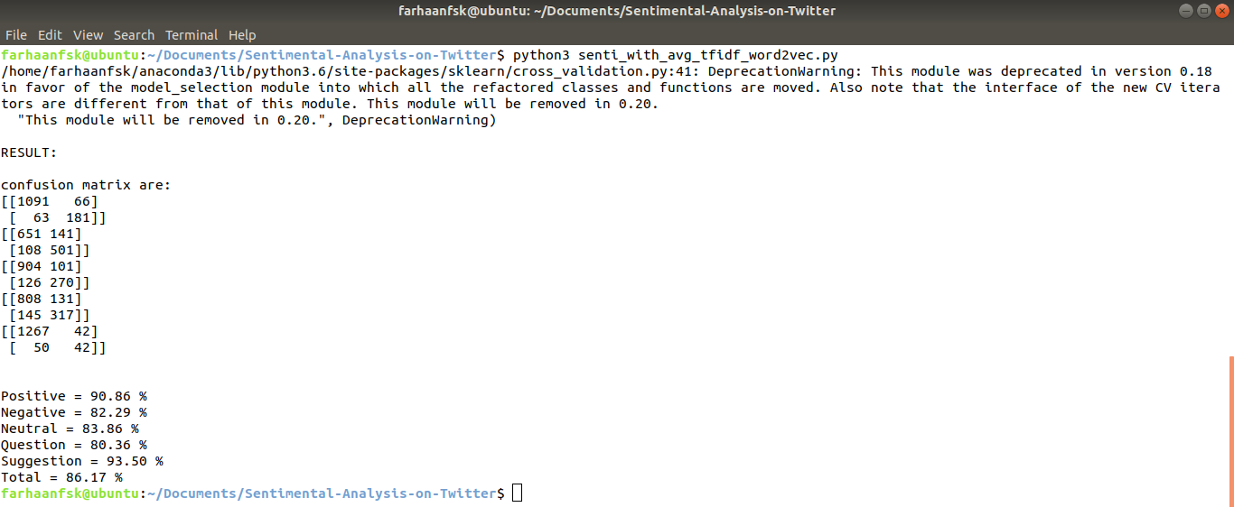
Fig.7.1 Output of 7000 tweets with TF-IDF Word2vec
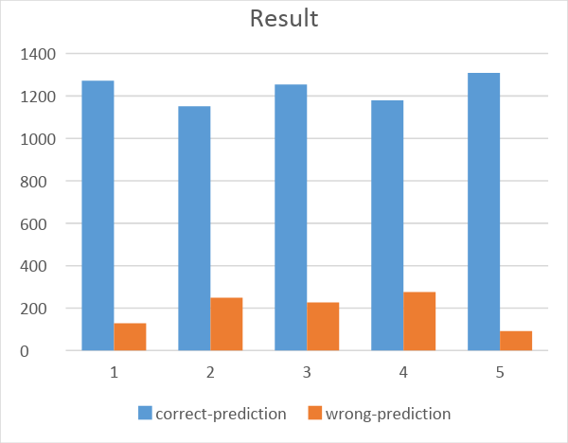
Fig.7.2 Bar Chart -1
In the dataset of 7000 Airline review tweets, 80% of the tweets are trained and 20% are tested or predicted. Below is the bar-chart (fig.7.4) which shows the overall number of tweets that are predicted correctly and the number of tweets that are predicted wrong. Only using word2vec resulted in an 81.30% classification model accuracy
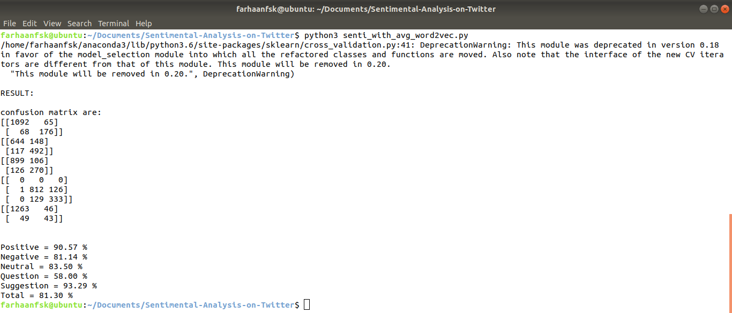
Fig.7.3 Output of 7000 tweets with Word2vec
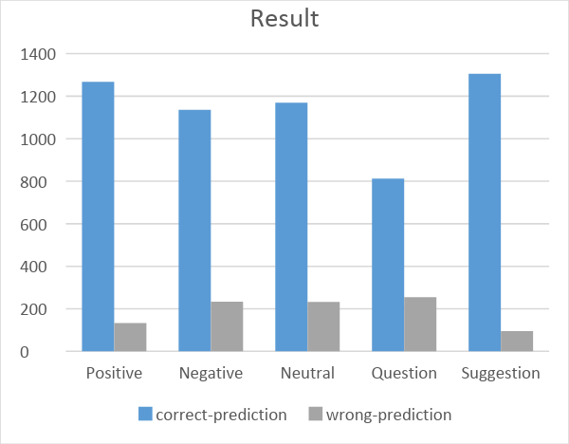
Fig.7.4 Bar Chart -2
In the dataset of 5000 Airline review tweets, 90% of the tweets are trained and 10% are tested or predicted. Below is the bar-chart (fig.7.6) which shows the overall number of tweets that are predicted correctly and the number of tweets that are predicted wrong. The combination of tf-idf and word2vec resulted in 73.08% classification model accuracy
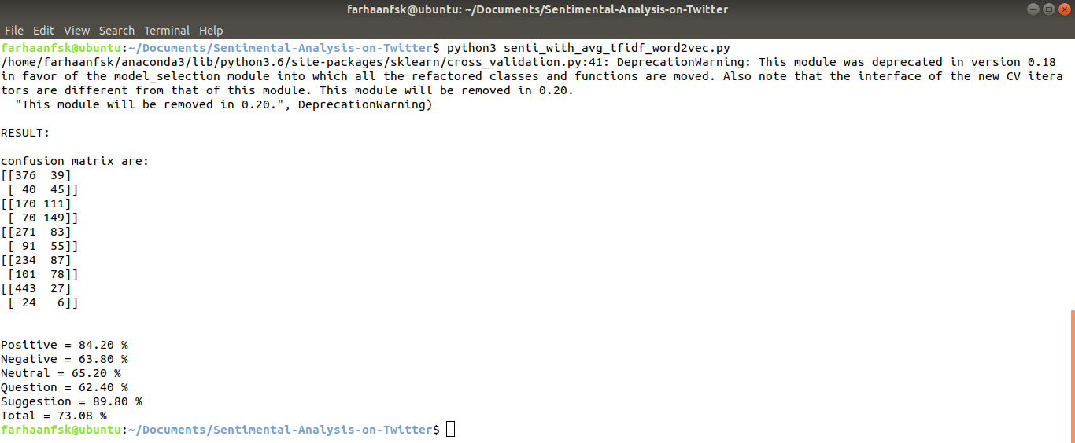
Fig.7.5 Output of 5000 tweets with TF-IDF Word2vec
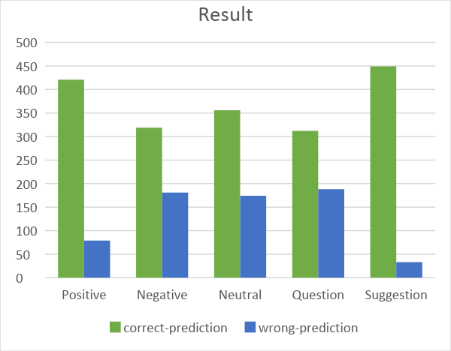
Fig.7.6 Bar Chart-3
In the dataset of 5000 Airline review tweets, 80% of the tweets are trained and 20% are tested or predicted. Below is the bar-chart (fig.7.8) which shows the overall number of tweets that are predicted correctly and the number of tweets that are predicted wrong. Only using word2vec resulted in an 72.24% classification model accuracy
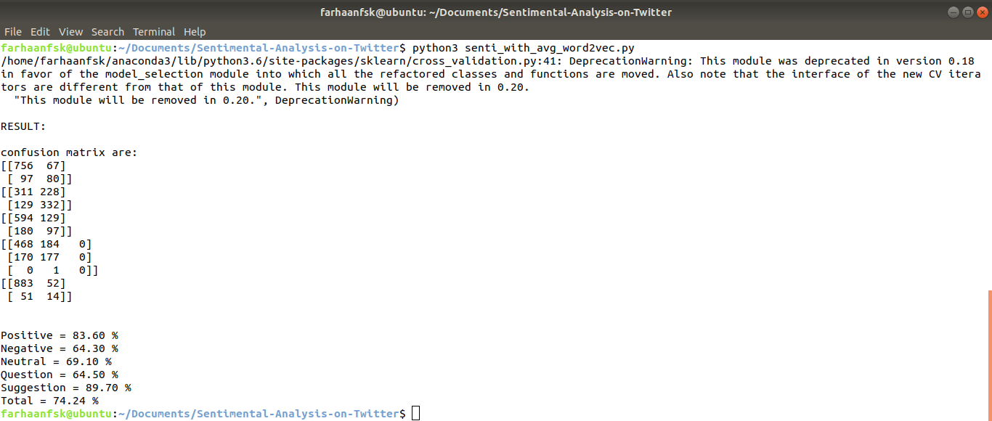
Fig.7.7 Output of 5000 tweets with Word2vec
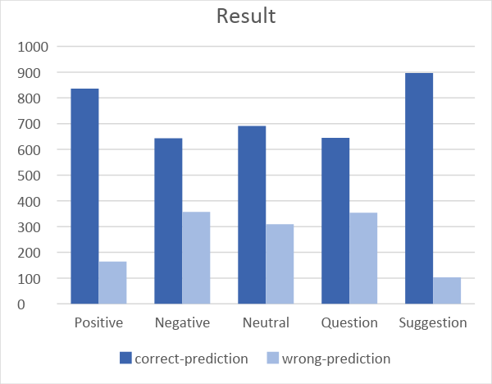
Fig.7.8 Bar Chart

CHAPTER-7
CONCLUSION AND FUTURE SCOPE

7. Conclusion and Future Scope
In this project, we have implemented Sentiment analysis or Emotion AI with two-layered neural network model Word2vec and deep learning model TF-IDF. We have added two more opinions Question and suggestion with the basic sentiments positive, negative and neutral to form a 5 vector model and have manually annotated 7000 tweets and with the help of Google’s predefined model which is a set of 3 billion words associated with 1X300 size vector. Word2vec input is a data corpus i.e. dataset and the output it produces is set of vectors for the words in the dataset. To the word2vec model we have embedded the TF-IDF approach to improve the accuracy. The accuracy can be further improved if more and more data is trained and then predicted.

CHAPTER-8
REFERENCES

References
[1] Y. Singh, P. K. Bhatia, and O.P. Sangwan, A Review of Studies on Machine Learning Techniques, International Journal of Computer Science and Security, Volume (1): Issue (1), pp. 70-84, 2007.
[2] E. Boiy, P. Hens, K. Deschacht and M. Moens, Automatic sentiment analysis in on-line text, 11th International Conference on Electronic Publishing, vol. 349360, 2007.
[3] Vincentius Riandaru Prasetyo, Edi Winarko. "Rating of Indonesian sinetron based on public opinion in Twitter using Cosine similarity", 2016 2nd International Conference on Science and Technology-Computer (ICST), 2016
[4] R. Feldman, Techniques and Applications for Sentiment Analysis, Communications of the ACM, Vol. 56 No. 4, pp. 82-89, 2013.
[5] J. Kamps, M. Marx, R. Mokken and M. De Rijke, 'Using wordnet to measure semantic orientations of adjectives', 2004.
[6] Gautam, Geetika, and Divakar Yadav. "Sentiment analysis of twitter data using Machine learning approaches and semantic Analysis", 2014 Seventh International Conference on Contemporary Computing (IC3), 2014.
[7] Neethu, M. S., and R. Rajasree. "Sentiment Analysis in twitter using machine learning techniques", 2013 Fourth International Conference on Computing Communications and Networking Technologies (ICCCNT), 2013.
[8] E.Boiy, P.Hens, K.Deschacht, and M.-F. Moens, "Automatic sentiment analysis in on-line text," in Proceedings of the 11th International Conference on Electronic Publishing, pp. 349-360, 2007.
[9] Mondher Bouazizi, Tomaki Ohtsuki, “A Pattern-Based Approach for Sarcasm Detection on Twitter”, IEEE Xplore journal volume 5, 2017.
[10] https://deeplearning4j.org/word2vec.html

CHAPTER-9
PUBLISHED PAPER

 | International Journal of Engineering & Technology, 7 (x) (2018) xxx-xxx  International Journal of Engineering & Technology  Website: www.sciencepubco.com/index.php/IJET  doi:  Research paper, Short communication, Review, Technical paper | 

Multi-class Emotion AI by reconstructing linguistic context of words

K. Sripath Roy ¹, Farhaan Ahmed Shaik ^{2*}, K. Uday Kiran ², M. Naga Teja², Subhani Kurra ²

¹ Asst Professor Department of Electronics and Communication Engineering, Koneru Lakshmaiah Education Foundation, Vaddeswaram, Guntur, Andhra Pradesh, India-522502
² Student, Department of Computer Science & Engineering, Koneru Lakshmaiah Education Foundation, Vaddeswaram, Guntur, Andhra Pradesh, India-522502
*Corresponding author E-mail: farhaanfsk@gmail.com.

Abstract

In today’s technological world, Social networking websites like Twitter, Instagram, Facebook, Tumblr, etc. play a very significant role. Emotion AI is about dealing, recognizing and analyzing sentiments or opinions conveyed in a person’s text. In particular Emotion is most frequently called Sentiment analysis. It helps us to understand the people’s point of view. A vast amount of sentiment rich data is produced by Social networking websites in the form of posts, tweets, statuses, blogs etc. Some users post reviews of certain products in social media which influences customers to buy the product. Companies can use such review data analyze it and improve the product. Sentiment analysis of Twitter is troublesome correlated to other social networking websites because of the existence of a lot of short words, misspellings and slang words applying emotion analysis to such data is more challenging. We have classified the sentiment into 5 categories. Machine learning strategies are preferred mostly for analyzing emotion AI. We have used neural network model word2vec with TF-IDF approach to predict the sentiment of the tweet.

Keywords: Emotion AI, Machine learning, Sentiment analysis, TF-IDF, Word2vec.

1. Introduction

Technology is developing day-by-day because of the Internet. The Internet is a worldwide communication network with this, usage of social websites like Twitter, Facebook, Instagram, Tumblr etc. have increased. In fact, social websites have become a famous place where everyone expresses their opinion about anything i.e. either it may be a product or article or society issues. Everyone has right to express their feeling and many of them think a social website is the best place to express their feelings in the form of the social networking blogs, Tweets, posts, statuses etc.

Sentiment Analysis or Emotion AI is a mechanism for ‘computationally’ resolving or recognizing if certain text is neutral, negative or positive. Sentiment analysis is again called as Opinion mining that is computing the sentiment or opinion of the person. Sentiment analysis is used to establish the person's opinion towards a product or problem with the help of variables such as emotion, tone and context, etc. Business corporations value this approach to compute and investigate the public opinion of their products and company to improve the customer satisfaction towards them. Business corporations further use this opinion mining approach to collect critical opinion about a new product and identifying the problems in it. Sentiment analysis is used by the major multinational companies to obtain the impression on their products and with the help of that, they can design their business strategies. Twitter is one of the platforms where people post the opinion on major real-world subjects, current affairs, etc. The social media websites like Facebook, Twitter and Instagram produce trillions of megabytes of data 24/7. This vast amount of data is interpreted to figure out the sentiment of people on various problems. Although a lot of research is done in sentiment analysis our developed model is one of its first kind.
4. Proposed techniques
4.1 Euclidean Distance
In order to calculate the distance between two points, Euclidean is used. Euclidean distance will play a significant role to calculate the distance between words. Euclidean distance is used in many of classification algorithm such as K-Nearest Neighbour, Minimum Distance Classifier, TF-IDF etc. let p1 at (x1, y1) and p2 at (x2, y2), in a plane then the Euclidean can be calculated with the help of Pythagoras theorem by:
Distance =

4.2 TF-IDF
Tf-idf is an acronym for term frequency-inverse document frequency, it’s a way to grade the significant terms (or "words") in a document based on how often these terms appear across the whole document and across multiple documents and the tf-idf weight usually used in data retrieval and text data mining. Computing sum of tf-idf for each term is one of the simplest approaches.

A) Term Frequency (TF)
It computes how often a word or term appears in a record. Since every record is divergent in length, it is possible that the term appears more times in some documents than others. Term frequency can be calculated by how frequent a term t occurs in a record, normalized by dividing by the total number of terms in that record.

B) Inverse Document Frequency (IDF)
It computes how common a word is among all records, at the same time measuring Term frequency, every word is scrutinized as equally essential. Despite, there are certain common words like "the", "for", "is", "of" and "that" which appear in many documents very frequently but have little significant. Therefore we compute IDF by:

4.3 WORD2VEC model
Word2Vec is a cluster of models which helps derive associations between a term and its contextual terms or words. The cluster models are hollow, two-layer neural networks that are schooled to reestablish linguistic contexts of words. The two important model architectures inside are Skip-grams and CBOW. Word2vec model can be built with the help of Tensor flow, it is an open source machine learning framework developed by Google for research purpose.
A) Skip-gram
In Skip-gram model, a center word and a window of context (neighbor) words are chosen and context words are predicted out to some window size for each center word. So, the model goes to outline a probability distribution i.e. probability of a word occurring in the context given a center word and vector representations is chosen to maximize the probability.
B) Continuous Bag of Words (CBOW)
In Actual terms, this is a mirror of skip-gram. In CBOW, we predict center word by summing vectors of surrounding (Neighbour) words. Essentially, we begin with small random initialization of word vectors. In Word2vec, we have a large matrix with each row for the “words” and columns for the “context”. CBOW is not sequential and does not have to be probabilistic.
3. Flow of process

Tweet Annotation
Result
Processing of Tweets
Data Collection
(Raw Tweets)
Training
& Testing

TF-IDF Word2vec Model
TF-IDF
Average
Word2vec

Fig.1.Flow of Process

5. IMPLEMENTATION
5.1 Data collection
Collection of data is one of the biggest tasks in sentiment analysis. Twitter data is abundantly available on twitter official website. Twitter provides a standard search API for research purpose. Access_token_ secret, Access_token, Consumer_secret and Consumer_key are required to access the Twitter API, to obtain these keys an application is to be created in dev.twitter.com. We have developed a simple python script with the Twitter API access keys and used it to download the specific tweets of a topic from the Twitter API to form the dataset. This raw dataset obtained through python script is cleaned and processed for prediction.

5.2 Data pre-processing
In Sentiment analysis, preprocessing of data plays a vital role as data always may not be in the exact (meaningful) form for analysis. Twitter data preprocessing is more significant as it consists of slang words, misspellings, #tags, @tags, hyperlinks and shortcut words. So we use various processing techniques like:
- Removing duplicates i.e. retweets and repeated tweets that are downloaded.
- Replacing the Null values with Zeros.
- Tweet of length less than 3 are deleted.
- Tags and hyperlinks have been eliminated.
- Stemming or lemmatization to obtain the base word.
- Removing stop words from each tweet.
Caution is required when removing stop words and lemmatization because some words like Not, Very, Limit etc. make sense in many statements. For overcoming this problem we use bigrams or trigrams instead of unigrams. Sometimes with Stemming or lemmatization, the base word obtained is not relevant to the tweet, such problems should be specifically checked.

5.3 Tweet Annotation
Generally, the output of sentiment analysis of any statement falls into three categories, they are positive, negative and neutral. Since the chosen dataset is on Airlines review tweets, we add two more essential categories question and suggestion. Since new categories added auto-annotation of emotion is not possible. So, each tweet is manually annotated. Tweets sometimes consist of both positive and negative or a negative and question but general sentiment analysis only assigns a single outcome to the tweet. As an improvement to this, multiple assignments to each tweet is done, For example:

- “@united I have such a love-hate relationship with you. Some days you're good, the others you are so terribly awful it's saddening”. We annotate such tweet as both Positive and Negative.

- “@VirginAmerica, you're doing a great job adding little luxuries/aesthetics that improve the air travel experience. Thank you. Keep it up!”. We annotate such tweet as both Positive and Suggestion.

- “@SouthwestAir, been on hold for an over an hour now - when can we expect some customer service? #disappointed”. We annotate such tweet as both Negative and Question.

5.4 TF-IDF word2vec model

Word2vector is a super-powerful representation of words and it somehow catches the semantic relationship in d-dimension vector. Word2vector gives Dense network i.e. most of the cells are non-zero.Word2vector learns the Data corpus through Word-Content or context. Suppose , , , , are the words in a corpus then in order to compute i.e. occurs in the context of the set of 5 words chosen. Let , , , , are the words in a tweet. So, We form 300 dimension vector for every word from Google's model and we add all these vectors (++++) and divide that with total no of words let it be K ((++++)/K). With this, we get a single vector of size 1*300 dimension for every tweet. For this algorithm, we need a large data corpus i.e. in billions or millions.
Since only limited data is available it is not feasible to build a word2vec model of our own. Instead, it is preferred to use Google's word2vector model. It consists of 3 billion words and each word is associated with 1X300 size vector. By using this model we create a combined model of “word2vec" and "TF-IDF" to form TF-IDF word2vec model.

6. Training & Testing dataset
After annotation of the dataset, we break the dataset into a couple of parts, Training data and Testing data. The number of tweets in the training data should be always greater than the testing data for the better result. Each tweet from test dataset is matched with a similar tweet from train dataset with the help of the constructed model “TF-IDF Word2vec” and various distance calculation algorithms like Euclidean distance, Manhattan, Minkowski, Hamming, cosine similarity and cosine distance. It is found that Euclidean distance is far better than others after multiple trails on the airline's dataset. We predict the class variables by using the above technique i.e. Euclidean distance and assign the same values as the near tweet consists of the test tweet. By using these similarity-based techniques we predict the sentiment of each user data or tweet.

7. Result
In the dataset of 7000 Airline review tweets, 80% of the tweets are trained and 20% are tested or predicted. Below is the bar-chart (fig.3) which shows the overall number of tweets that are predicted correctly and the number of tweets that are predicted wrong. The combination of tf-idf and word2vec resulted in an 86.14% classification model accuracy

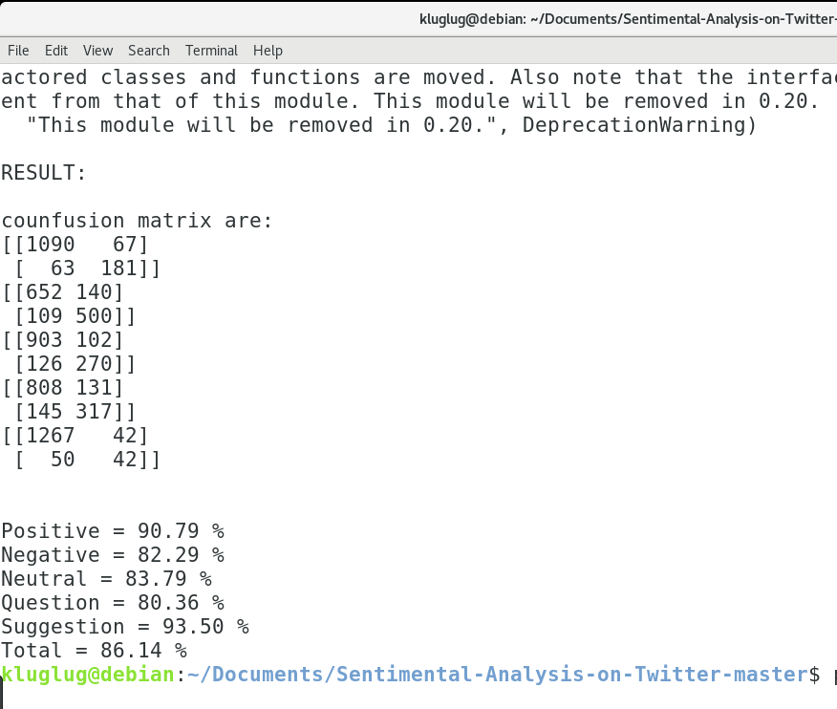
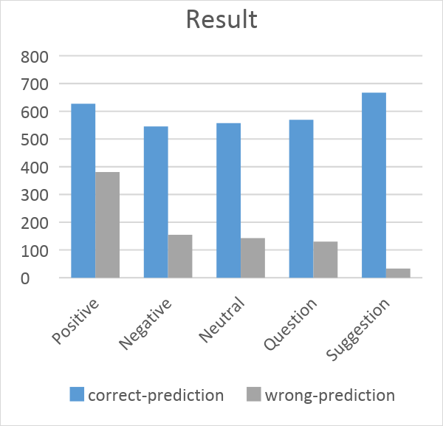
Fig.2.Output

Fig.3.Result

8. Conclusion and Future Scope

In this paper, we have implemented Sentiment analysis or Emotion AI with two-layered neural network model Word2vec and deep learning model TF-IDF. We have added two more opinions Question and suggestion with the basic sentiments to form a 5 vector model and have manually annotated 7000 tweets and with the help of Google’s predefined model which is a set of 3 billion words associated with 1X300 size vector. Word2vec input is a data corpus i.e. dataset and the output it produces is set of vectors for the words in the dataset. The accuracy can be improved if more and more data is trained.
References

[1] Y. Singh, P. K. Bhatia, and O.P. Sangwan, A Review of Studies on Machine Learning Techniques, International Journal of Computer Science and Security, Volume (1): Issue (1), pp. 70-84, 2007.
[2] E. Boiy, P. Hens, K. Deschacht and M. Moens, Automatic sentiment analysis in on-line text, 11th International Conference on Electronic Publishing, vol. 349360, 2007.
[3] Vincentius Riandaru Prasetyo, Edi Winarko. "Rating of Indonesian sinetron based on public opinion in Twitter using Cosine similarity", 2016 2nd International Conference on Science and Technology-Computer (ICST), 2016
[4] R. Feldman, Techniques and Applications for Sentiment Analysis, Communications of the ACM, Vol. 56 No. 4, pp. 82-89, 2013.
[5] J. Kamps, M. Marx, R. Mokken and M. De Rijke, 'Using wordnet to measure semantic orientations of adjectives', 2004.
[6] Gautam, Geetika, and Divakar Yadav. "Sentiment analysis of twitter data using Machine learning approaches and semantic Analysis", 2014 Seventh International Conference on Contemporary Computing (IC3), 2014.
[7] Neethu, M. S., and R. Rajasree. "Sentiment
Analysis in twitter using machine learning techniques", 2013 Fourth International Conference on Computing Communications and Networking Technologies (ICCCNT), 2013.
[8] E.Boiy, P.Hens, K.Deschacht, and M.-F. Moens, "Automatic sentiment analysis in on-line text," in Proceedings of the 11th International Conference on Electronic Publishing, pp. 349-360, 2007.
[9] Mondher Bouazizi, Tomaki Ohtsuki, “A Pattern-Based Approach for Sarcasm Detection on Twitter”, IEEE Xplore journal volume 5, 2017.
[10] https://deeplearning4j.org/word2vec.html

